35.40: Destructive interference occurs 1.7 m from the centerline.

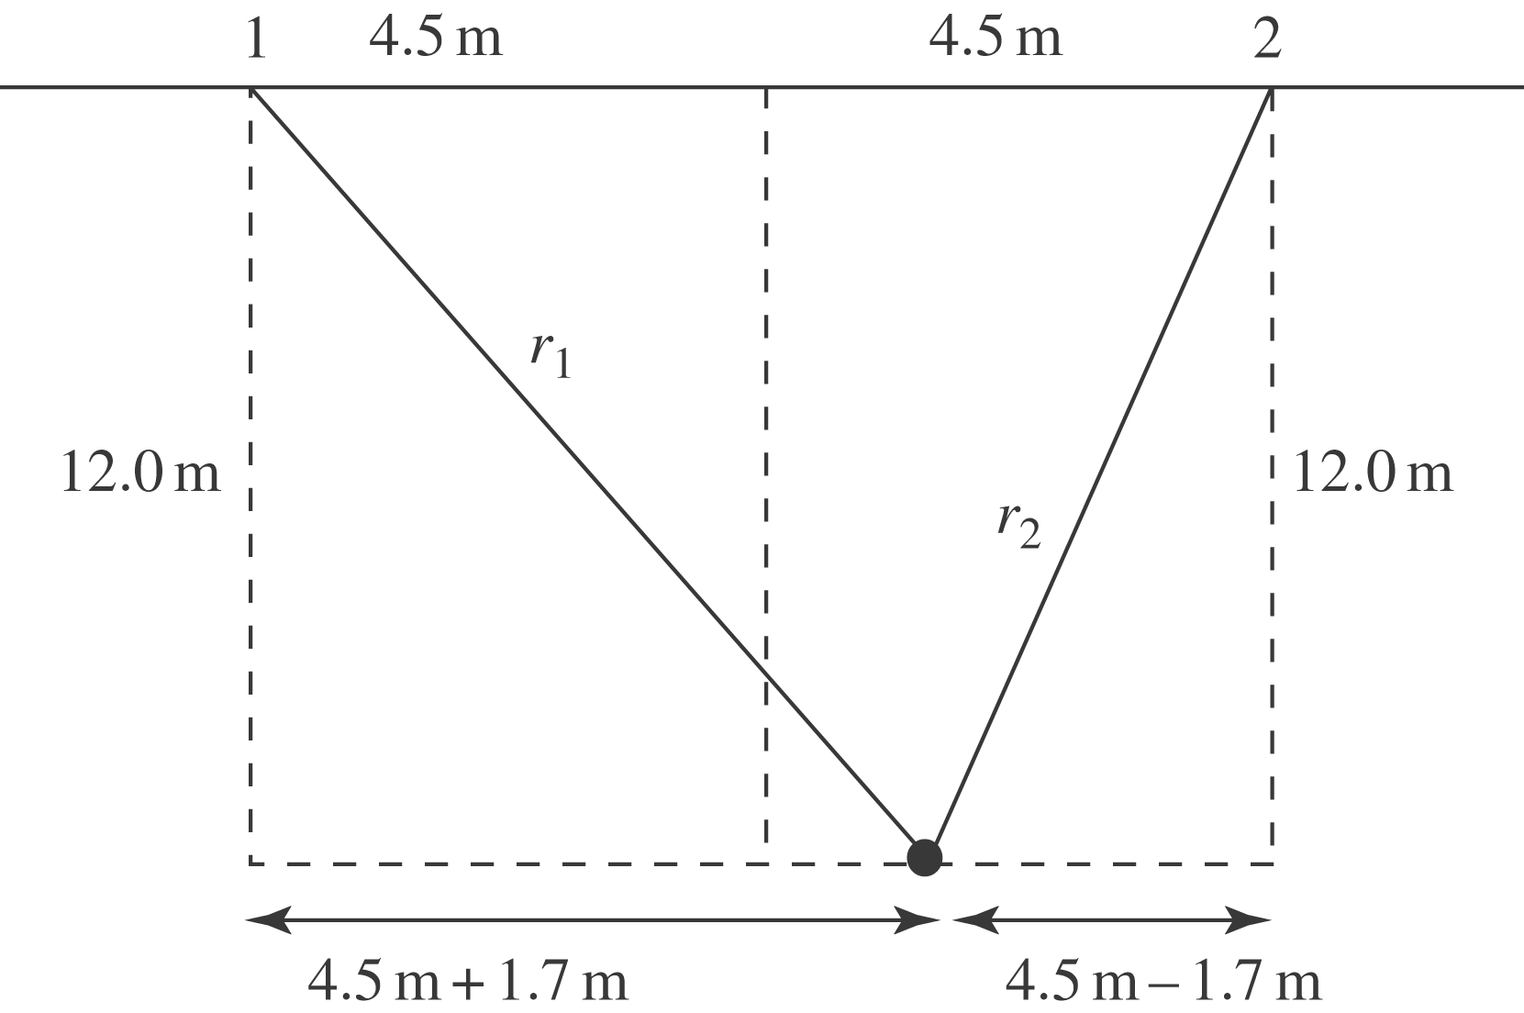

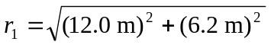=13.51 m
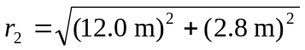=12.32 m
For destructive interference, 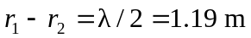and 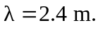The wavelength we have calculated is the distance between the wave crests.
Note: The distance of the person from the gaps is not large compared to the separation of the gaps, so the path length is not accurately given by 